Researching apprenticeships

Apprenticeships are primarily jobs, so it’s important to research this option fully. They offer the opportunity to:
- start work, earn a wage, and continue studying at a higher level
- gain knowledge, skills, and experience for specific careers

The first thing to do, if you haven’t already, is make sure you sign up to your UCAS Hub.
This will give you all the tools and information you need – in one place. You can easily explore, filter, and favourite the things which matter to you most.
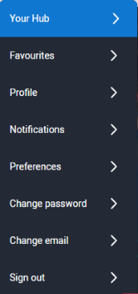
How do I sign up?
The UCAS Hub is free and easy to use. All you need to do is follow these three simple steps to sign up:
Step 1 – Register
To get started, visit ucas.com/hub.
Step 2 – Verify your account
Once you’ve completed your registration details you’ll be asked to verify your account by entering a code we’ve emailed you.
All you need to do is copy the code from the email and hit the verify button
Step 3 – Sign in
Now you’re ready to sign in and start exploring! The first time you do, we’ll ask you some extra questions so we can help you find the right info.
At any time to pick up where you left off, click ‘Sign in’ on the top right-hand side of any page on ucas.com, and navigate to ‘Your Hub’.

Activity 1: I think I want to do an apprenticeship
Here are some of the key things you need to know:

- Apprenticeships involve training for a specific job, so it’s important you’re confident about starting work.
- You should find out as much as you can about the job role, and the career and progression routes the apprenticeship could lead to.
- Competition for apprenticeships can be tough, as there’s often a limited number of vacancies available, particularly on degree level apprenticeships.

But, this isn’t enough to help you decide if it’s the right path for you, and according to research, nearly two-thirds of 16-24 year olds feel they don’t know enough about apprenticeships.
Use the links to find out more about apprenticeships and find answers to the questions in the table below.
Understand more about apprenticeships on ucas.com or your national apprenticeship website – including real-life stories from current apprentices.
- Everything you need to know about UK apprenticeships  - What you need to know about apprenticeships  - Start your journey to an apprenticeship by exploring industries that might suit you  - How I got my apprenticeship | • England  • Wales  • Scotland  • Northern Ireland

What are the expected apprenticeship hours?

How will the employer split your working week between study and work?
What are the different levels of apprenticeships available?
What apprenticeship level could be right for you?
Can you apply for an apprenticeship and university at the same time?

How do you apply for an apprenticeship?
What time of year do apprenticeships start?
Who pays for apprenticeship training?
What is the minimum wage for an apprentice of your age?
Can you list five professions/industries you didn’t know offered apprenticeships?
Can you name three businesses/employers offering apprenticeships that surprised you?
What are the three pros and cons of apprenticeships for you?

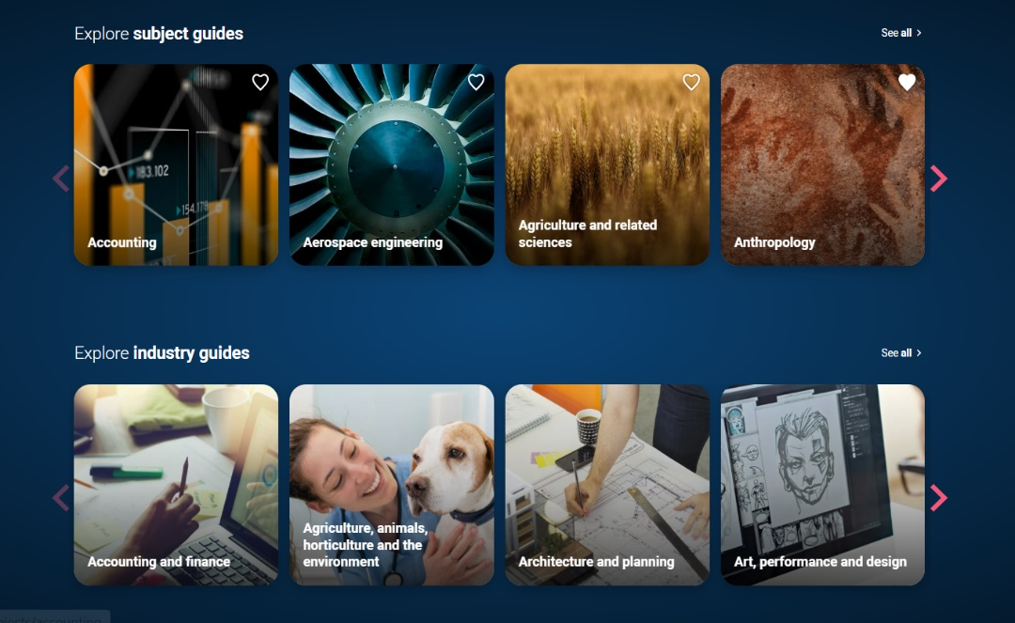
Activity 2: Explore the jobs available
Start your research on apprenticeships in your UCAS Hub, and explore our industry guides to find out more about the areas you’re interested in.
You’ll also find details about apprenticeship in our subject guides. They contain links to the apprenticeship standards (at different levels). These are important as they explain the skills, knowledge, and behaviours required to demonstrate that an apprentice is fully competent in the job role, and so will help you learn more about what you would have to do.
- Draw up a list of three apprenticeships you want to explore further.
- For each one, investigate the apprenticeship standard. To really understand more and if you might be a good fit, see if you can complete the table below.
As you’re exploring on ucas.com, remember to favourite anything you’re interested in by clicking on the heart. This will pin any ucas.com page to your UCAS Hub dashboard, so you can come back to it easily at any time.

Apprenticeship (sector/industry) | Apprenticeship Level | Apprenticeship standards  Skills I want to build | Apprenticeship standards  Knowledge I want to learn | Apprenticeship standards  Behaviours I want to develop
1.
2.
3.
UCAS Hub top tip
Don’t forget to look at what is coming up live in the UCAS Hub – you can join these ‘Hub live’ sessions throughout the year. We’ve teamed up with careers, higher education, and application specialists to help you take your next steps. Plus, we’ll be talking to current uni students and apprentices who will be bringing you some serious insight on student life, the things they wish they knew, and how to choose the right path for you. So, whether you’re looking for practical tips or some inspiration, we’re here with the experts to help. Best of all they are all recorded so you can watch any you might have missed on demand!
How to get involved
To get involved, all you need to do is sign in to your Hub on the day of the live session at 15:00 (UK time) and there will be a button at the top of the page inviting you to join. Listen in, ask questions, and get the answers you need to help with your next steps.

Activity 3: What role would suit you?
Find all you need to know about apprenticeships through the UCAS Hub – explore live vacancies and employers, and sign up to Career Finder.
Career Finder is where you can search and apply for apprenticeships, jobs and internships, get job alerts, and keep tabs on your applications.
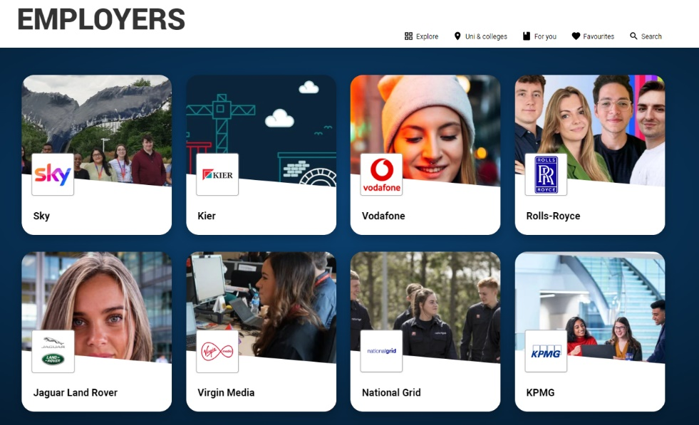
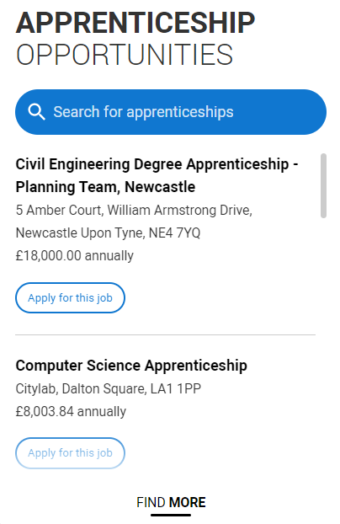

Here are some of the things you need to think about. You can check out the employer’s own website for further details and information. If you’re considering an apprenticeship, also contact the employer, university, college, or training provider, to ask any questions you have.
What you need to find out | Opportunity 1 | Opportunity 2 | Opportunity 3 | Opportunity 4 | Opportunity 5
Job role description – does it fit what you’re looking for? What work is involved in the apprenticeship? Does it offer opportunities for career progression?

Who is the employer? Is this the type of company you want to work for? Can you travel there each day?
Does the job require you to work in different locations across the country, or would you need to move away from home?

What is the pay or salary, and do they offer other benefits or facilities? Is there career progression?
Who is the training provider? What is the college or university like where you’ll be studying? Can you travel there?
Entry requirements – what qualifications, experience, skills, subjects, and grades are they looking for?
What essential and desirable skills are they looking for? Do you have the experience and qualities they are looking for in applicants?
Have you looked at the apprenticeship standards?
What are the three pros and cons of this apprenticeship/job role?

Top tip
Don’t forget, once you’re ready to apply, take a look at our careers advice and check out how to apply for an apprenticeship and how to prepare for an apprenticeship interview on ucas.com.

